
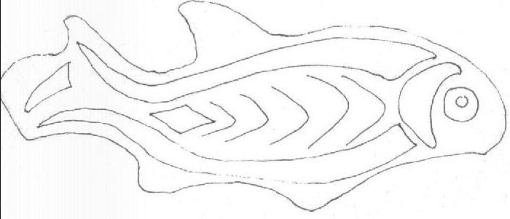


These animal designs are all taken from Roman brooches that have been recorded by the Portable Antiquities Scheme.
There is a fish and a hare. Can you tell what the other one is?
The Romans loved bright colours. Why not colour these in?
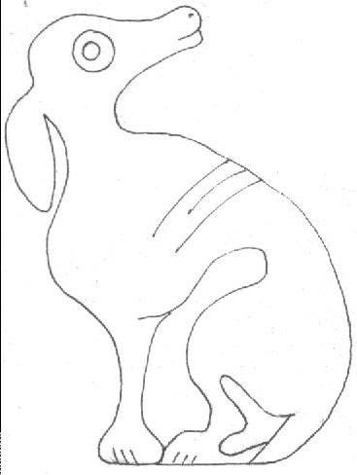
If you would like to find out more, go to www.pastexplorers.org.uk

In the space, create your own Roman style animal design!

